**Carelon Global Solutions AWS Data Engineer Interview Guide – Experienced 3+**

**Interview Rounds Overview**

1. **Round 1 – Technical**

• Focused on PySpark, SQL, and AWS S3 fundamentals and operations.

2. **Round 2 – Techno-Managerial**

• Covered Spark, Snowflake, AWS Services, and end-to-end data pipeline architecture.

3. **Round 3 – HR Discussion**

• Focused on cultural fit, company policies, and salary discussions.

**Detailed Breakdown of Rounds**

**Round 1 – Technical**

**Key Topics & Questions**:

1. **PySpark and AWS S3**:

• Write PySpark code to save a DataFrame in Parquet format to an S3 bucket.

• Explain how to overwrite a file stored in S3 using PySpark.

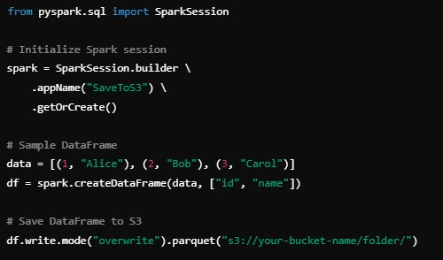

2. **AWS S3 Versioning**:

* Discuss how versioning works in S3 and its use cases, such as data recovery and auditing.

3. **SQL Query Challenge**:

Write a query to generate the specified output. This tested advanced SQL skills with joins, aggregations, and window functions.

4. **Running PySpark on AWS EC2**:

• Steps to execute a Python file with PySpark code on an EC2 environment, emphasizing environment setup, JAR dependencies, and S3 integration.

5. **File Copying to S3**:

• Methods to copy files to S3 without using the bucket upload feature, such as using the AWS CLI or Python's boto3 library.

6. **Snowflake vs. Spark**:

• Time and cost comparisons for executing the same query in Snowflake and

Spark.

• Discussed cost optimization techniques for Snowflake, such as utilizing clustering keys and data compression while loading data from S3.

**Round 2 – Techno-Managerial**

This round was conducted in two phases and focused on assessing my expertise with AWS

data engineering services and Spark optimization techniques.

**Key Questions**:

1. **Spark Memory Distribution**:

• Explain how Spark processes a 500GB file, covering memory allocation, shuffles, and spillovers to disk.

2. **Architecture-Level Scenarios**:

• Designing an end-to-end data pipeline using Glue, Lambda, EC2, S3, Redshift, and Athena.

3. **PySpark Program**:

• Write a complete PySpark program from import statements to the stop statement, covering transformations and actions.

4. **SQL Challenges**:

• Tested SQL skills using advanced window functions such as LAG, LEAD, and

DENSE_RANK.

• Practical examples focused on ranking and trend analysis.

5. **Spark Optimization**:

• Discuss techniques such as partitioning, broadcast joins, and caching to enhance Spark job performance.

**Round 3 – HR Discussion**

**Topics Covered**:

1. **Team Culture**:

• Discussion around the company's values, team dynamics, and expectations.

2. **Work Policies**:

Details on leave policies, holidays, and work flexibility (e.g., hybrid vs. remote).

3. **Compensation**:

• Negotiated salary, including fixed and variable components.

4. **Work Culture**:

• Insight into the company’s work-life balance and career growth opportunities.